Vau Tech IT solutions
Intern - Machine Learning
Intern Period – 1st January to 30th March 2026
Name -Kaushal Raut
Intern Id – VT26ML001
Mentored By – Mr. Vishal Rajbhar Sir

Abstract

This documentation explains how real-world problems can be converted into Machine Learning problems. The main goal of this task is to help understand how to identify a suitable industry problem and decide the correct type of machine learning approach such as classification, regression, or clustering. It also describes how to select the right input features and define the target variable for the model. Additionally, the documentation clearly states the machine learning objective and the expected output. By completing this task, learners gain a basic understanding of how to analyze real-life problems and frame them properly for machine learning solutions.

1.Introduction
What is Machine Learning ?
Machine Learning (ML) is a subset of Artificial Intelligence that enables systems to learn from data and make decisions or predictions without being explicitly programmed. One of the most important steps in building an ML solution is correctly identifying the problem. If the problem is not identified properly, even the best algorithms may fail to deliver useful results.
This documentation focuses on understanding how real-world problems can be converted into Machine Learning problems by following a better approach.

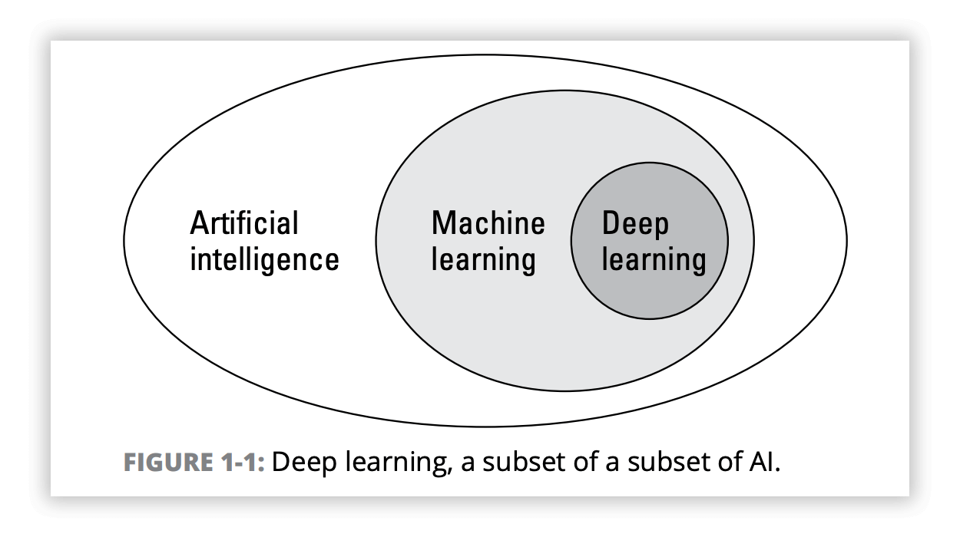

2.Task Overview –
Task Title – Machine Learning problem identification and framing
Task Description – Understand how to convert Real world problems into machine learning problems .
Objective –
- Choose a suitable industry use case
- Identify the type of ML problem (Classification, regression and clustering )
- Define input features and target variable
- Clearly state the ML objective and expected output .

Learning Outcome -
After completing this task, I learn how to –
- Analyze real world problem and how to solve by using ML concept .
- Decide appropriate ML technique to used
- How to define input feature and target variable (output)

3. Industry use case selection
Selected industry = E-commerce
Use Case – Product Recommendation System

Description -
E-commerce platforms contain a large number of products. And Showing all the products to every user is not practically possible and may also affect user experience . Customers often prefer products based on their interests, past behavior, and preferences.

4.Problem Statement
An e-commerce platform needs to recommend relevant products to users based on their preferences and recent activities and it is not possible to display all available products to each user.
The goal is to improve user experience and increase engagement on the application by showing personalized product recommendation 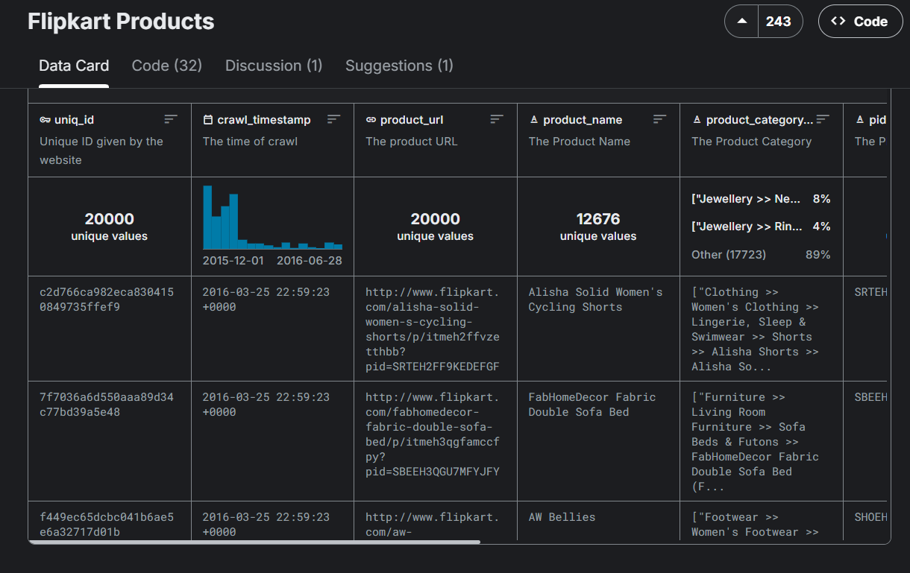

5.Type of Machine learning problem
Identify ML type – Classification (Supervision)
Justification - the system classifies products into two categories –
- Recommend
- Do not recommend
Based on the user recent activity and preferences, the model decides whether a product should be recommended to a specific user.

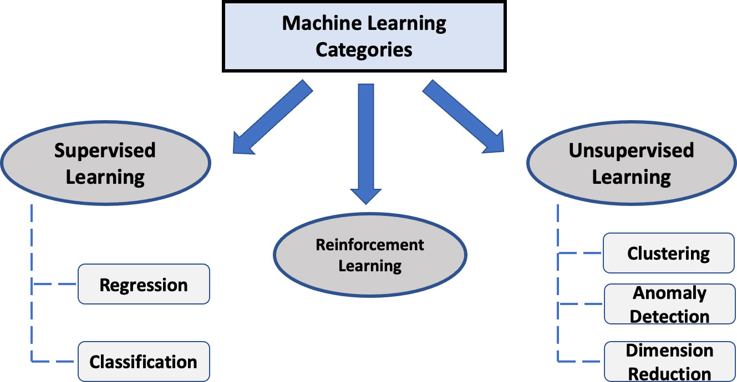

6.Input Feature
Input features mean the data that has been provided to the ML model to make future decision/Prediction .
- Selected Input features (data given to the model )
  - Product category
  - Recently viewed/searched product
  - User price range
  - Favourate brand of user
  - Recently purchased product
  - Current festival /event
Importance of input feature
It helps the model to understand user preferences and seasonal interest which helps to recommend products more accurately.
7. Target variable
Definition-Target variable means the output that has been predicted by model .
Target variable in this model -products to be recommended to the user
Provides a list of products which should be recommend and which should be not.

8.ML objective and expected output
Machine Learning Objective:
The objective of this machine learning model is to recommend relevant products to users by analyzing product details such as category, brand, price, discount, and ratings. The model learns user preferences and helps in showing only those products that match the user’s interests.
Expected Output:
The expected output is a list of products that should be recommended to the user. Each product is classified as either “Recommend” or “Do Not Recommend” based on the user’s preferences and product features.

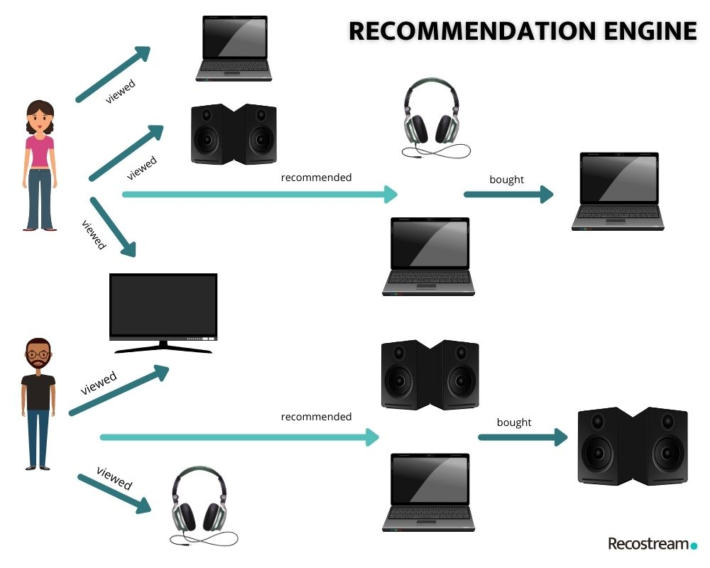

8.Conclusion
This documentation explained how a real-world e-commerce problem can be converted into a machine learning problem. By identifying the correct ML type, defining input features and target variables, and clearly stating the objective, we can design effective ML solutions. Proper problem identification and framing form the foundation of any successful machine learning project.

